**JUMBLED IN THE BRONX -**   
Exploring Neighborhood Venue Popularity to Predict Business Opportunity

INDEX

NO| TITLE |Pg

01 INTRODUCTION………………………………………….. 3

02 DATA SECTION………………………………………….. . 4

03 METHODOLOGY………………………………………….. 5

04 RESULTS……………………………………………………… 7

05 RECOMMENDATONS………………………………….. 8

06 CONCLUSION……………………………………………… 9

**INTRODUCTION**

* **SCENARIO & BACKGROUND**
  + Bronx is a borough in New York- the financial capital of USA.
  + The diverse neighborhoods offer a competitive but lucrative market for dining out and entertainment.
  + However the market is fiercely competitive and rentals are high.
  + Businesses require high turnovers for viability.
* **PROBLEM**
  + The challenge is to find an opportunity that suits the interest and tastes of a neighborhood.
  + At the same time the neighborhood must offer an opportunity gap and not be saturated or have highly popular similar venues.
* **REQUIREMENT**
  + An entrepreneur based out of Bronx, is looking to start a business in the area and wants a neighborhood analysis to setup a new restaurant or entertainment joint.
  + Having an ability to start any food or entertainment business, the idea is to look for opportunities in neighborhood and meet them with a new business venture.

**DATA SECTION**

* **DATA REQUIRED**[**¶**](https://e-9d8e0b14c5.cognitiveclass.ai/lab)
  + To attend to project requirements, we require data of New York neighborhoods by borough.
  + We also require data of popular venues visited through Foursquare API with frequency of visit for each venue.
* **DATA SOURCES**
  + The data for New York boroughs and neighborhoods including Bronx is obtained from following site: <https://cocl.us/new_york_dataset>
  + This basic data acquired from the above links is used to access Foursquare API data about venues in each neighborhood.
  + The most common venues are added to dataframe basis frequency received from API data
* **DATA LIMITATIONS**
  + Our project assumes that Foursquare user data represents the whole of the neighborhoods.
  + Due to popularity and wide usage of this API in NY, this is a reasonably safe assumption of being able to obtain a wide and representative data set.

**METHODOLOGY**

**STRATEGY**

* Strategy involves using data mentioned in Section 2 above.
* Neighborhood data will be used in tandem with foursquare API venue popularity data to classify neighborhoods.

**EXECUTION & ANALYSIS**

* We will consider what are the 10 most popular venues by neighborhood within the Bronx borough.
* We will sort most popular venues basis frequency of visits as recorded by Foursquare API user data.
* We will then classify the neighborhoods into clusters using K-Means clustering to group similar neighborhoods and separate dissimilar neighborhoods.
* We will then examine similar neighborhoods within a cluster to understand favorite venues by frequency within clusters.
* To be considered an opportunity gap, the neighborhood selected must not have the high frequency venues of its cluster in its top 5 most frequency venues.
* If the high frequency venues of cluster are already in top 5 of a neighborhood, the opportunity may be considered as saturated due to presence of ample or highly favored venues which will create an entry barrier.

Neighborhoods of Bronx

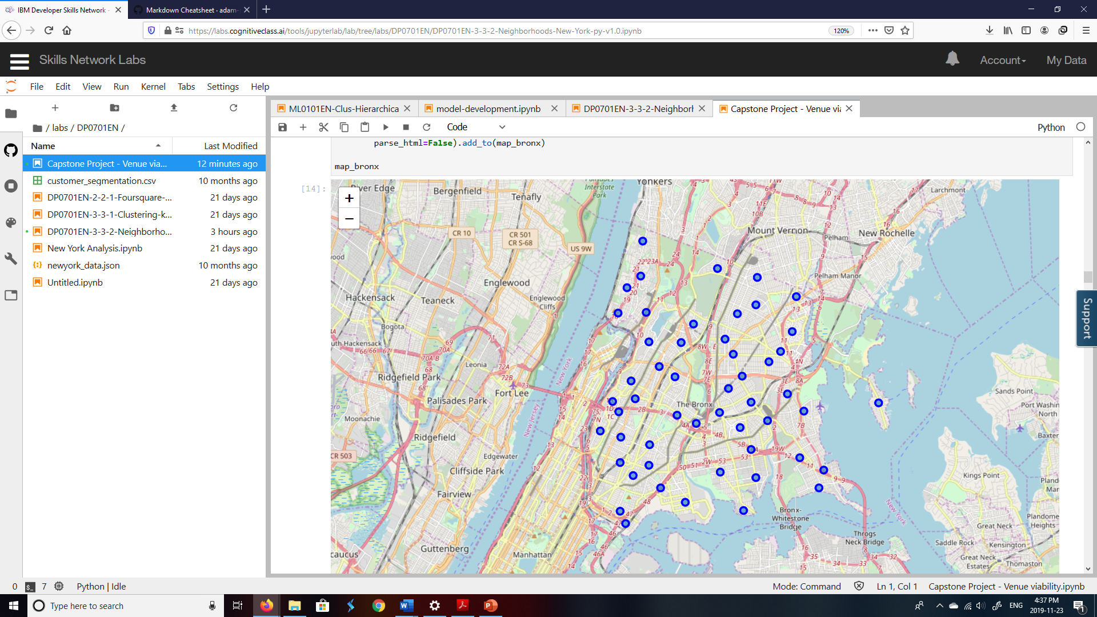

We will classify the 52 neighborhoods within Bronx basis venue popularity data from Foursquare API

K-Means Cluster Analysis

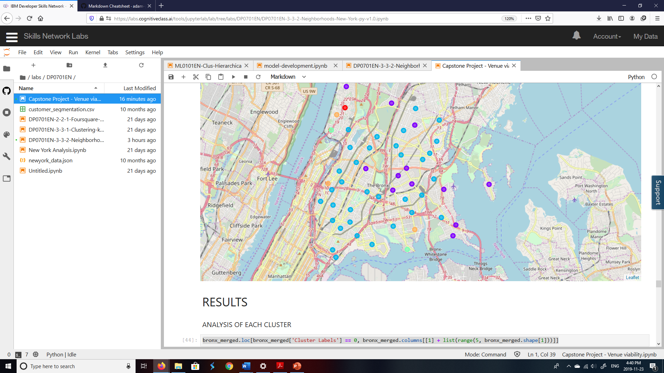

* We classify the neighborhoods into 5 clusters with K-Means Analysis.
* Cluster 2 with 12 neighborhoods (in purple) is an ideal cluster for further evaluation.

**RESULTS**

Reasonable size of neighborhood clusters with similar popularity of venues is seen in cluster 2

* + Pizza places occur frequently as a popular venue. Opportunity exists in locations like Bronxdale,Country Club & City Island neighborhoods which do not have pizza place in top 5.
  + Second most popular are Deli/Bodega with opportunity gaps in Pelham Parkway, City Island, Country Club, North Riverdale, Edenwald & Bronxdale
  + Third most popular are Italian restaurants with opportunities in 7 of the neighborhoods.

With 34 similar neighborhoods, we may look at sub-classifying cluster 3 further before exploring opportunities in these neighborhoods

* + With present analysis the 7 most popular venues in order starting from most popular are Donut Shop, Pizza place, Supermarket, Pharmacy, Chinese Restaurant, Fast Food Restaurant and Sandwich place.
  + We will ignore Supermarket & Pharmacy and consider the remaining 5 possibilities as our scope is limited to Food or entertainment business.

Clusters 1, 4 and 5 have between 1-3 neighborhoods and hence we will not prioritize these options as they limit geography and also may not provide ample opportunity.

**DISCUSSIONS / RECOMMENDATIONS**

Reasonable size of neighborhood clusters with similar popularity of venues is seen in cluster 2. This makes an ideal target geography to initiate business project. With 34 similar neighborhoods, we may look at sub-classifying cluster 3 further before exploring opportunities in these neighborhoods. Clusters 1, 4 and 5 have between 1-3 neighborhoods and hence we will not prioritize these options as they limit geography and also may not provide ample opportunity.

* Pizza places occur frequently as a popular venue. Opportunity exists in locations like Bronxdale,Country Club & City Island neighborhoods which do not have pizza place in top 5.
* Second most popular are Deli/Bodega with opportunity gaps in Pelham Parkway, City Island, Country Club, North Riverdale, Edenwald & Bronxdale
* Third most popular are Italian restaurants with opportunities in 7 of the neighborhoods.
* With present analysis of cluster 3, the 7 most popular venues in order starting from most popular are Donut Shop, Pizza place, Supermarket, Pharmacy, Chinese Restaurant, Fast Food Restaurant and Sandwich place. We will ignore Supermarket & Pharmacy and consider the remaining 5 possibilities as our scope is limited to Food or entertainment business.

**CONCLUSIONS AND FUTURE DIRECTIONS**

* Initial analysis provides a very reasonable geography of 10 neighborhoods within cluster 2 to explore rental properties for business with 3 popular venue options.
* Future sub-classification of cluster 3 can provide more options if required.
* Other data that can be explored include neighborhood demographics like age & preference for ethnic cuisine.